House Price Model

In order to run the prepayment model on forward projection paths, we need to get an estimate for the House Price Index (HPI). We have implemented a function named HpaModel in Scale to project HPI along forward paths.

- Model Inputs

The raw data Scale consumes is stored in a flat file, which contains the time series of Monthly, All-transaction, USA level HPI. The data set is originally a Quarterly series, but we create a monthly version by interpolating monthly numbers from quarterly HPI values.

Due to the quarterly release cycle, the gap between the latest prepayment data set and the latest HPI data will be somewhere between three to five months. For example, on 2017-06-01, we received the latest available HPI for 2017-03-01 (a three month lag). The next HPI release will not happen till 2017-09-01. So, on 2017-08-01, we will experience the longest lag of five months.

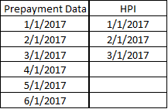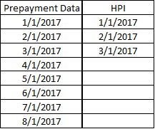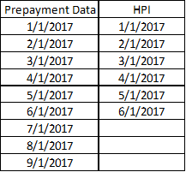
2017-06: 3-month lag 2017-08: 5-month lag 2017-09: 3-month lag

- Projection Model

- HPI Calculation

The HpaModel in Scale reads in the latest available HPI data, and then applies an assumption of “constant HPA”. For the latest available HPI at time t, Scale applies an annualized 3% constant HPA increase to calculate HPI at time t+1.
${HPI}_{t+1}={HPI}_{t}×{(1+constant annual HPA increase)}^{\frac{1}{12}}$

The calculation is applied from the first unknown factor date. For example, at 2017-08-01, the latest HPI is 2017-03-01 with value of 388.6. We estimate the next HPI number for 4/1/2017 by
${HPI}_{Apr}=388.6×{(1+3\%)}^{\frac{1}{12}}=389.6$

In other words, there is no other averaging or smoothing process. The HPI forward projection will all start from the latest HPI number (2017-03-01 HPI in the example).

- HPA-2Yr Calculation

After we get the full projection for HPI on the forward path, we also calculate the HPA-2Yr using the estimated HPIs. The HPA at time t is defined as the ratio of HPI at t and HPI at t-24:
${HPA 2Yr}_{t}=\frac{{HPI}_{t}}{{HPI}_{t-24}}$

After 24 factor estimations on the forward path, the two HPI terms both follow the estimation formula, so HPA-2Yr becomes a constant number:
$HPA 2Yr =\frac{{HPI}_{t}}{{HPI}_{t-24}}=(1+3\%){}^{\frac{24}{12}}=(1+3\%){}^{2}=1.0609$

Note the implication that all States have the same constant rate of home price appreciation going forward.

